# The Shape of the Troubles: Developing an Impulse-decay model for representing the effect of conflict-attributable excess deaths after 1972 in young adult males in Northern Ireland

## Introduction

Sectarian conflict often takes the form of tit-for-tat: they harm us, so we harm them (so they harm use, so we harm them…). Sectarian acts of violence beget further violence, the most extreme forms of which are killings, and where sectarian tensions have tipped over into homicidal acts and reprisals, additional deaths become visible in the demographic records of the affected populations.

The aims of this paper are to first *illustrate*, then secondly to formally *represent*, the *shape* that the mortality effects of sectarianism in Northern Ireland had on young adult male mortality risks in the early 1970s and subsequent decades, a period commonly known as the Troubles. By *illustrating* this shape, I mean presenting mortality rates as a Lexis surface, a tiled arrangement of coloured values, each row a different age, and each column a different year. By *representing* the shape, I mean developing a statistical model specification which incorporates the key structural feature, the ‘shape of the Troubles’, which was identified through Lexis surface visualisation.

I represent the ‘shape of the Troubles’ through an Impulse-decay (ID) function, which has two properties. Firstly, it has a clear *time of onset (or ‘impulse’)*, with no visible mortality effect before this time, and a substantial effect afterwards. Secondly, after onset, the intensity of the effect *decays exponentially* with time. At an aggregate level, with access only to numbers of deaths and population sizes by age, year and gender, and not to additional information on cause of death or social group affiliation, this ID function appears to provide a reasonable representation of excess mortality likely due to sectarian conflict of a tit-for-tat character. I would argue it is an ‘efficient’ way of producing such estimates, which can produce reasonable inferences about the human toll of such conflicts given only standard demographic data. This means it has value for estimating the deaths attributable to other conflicts across the world where the more meticulously collected records of conflict-attributable deaths made in Northern Ireland’s case are not available.

## Background and Intuition: Mortality in Northern Ireland compared with its Neighbours

Before providing a more formal description of the mortality model introduced above, it is useful to present some of those visualisations which led to the model being developed in the first place. As with much research, the origins of this paper are in a surprising but incidental finding in a previous paper [REDACTED]. Because the methodology employed in this paper is unusual and builds on the methodology of the earlier paper, this background section will focus on methodology rather than the history of violent sectarian conflict in Northern Ireland; the appendix contains further details on this history.

In this earlier paper, the substantive focus was on understanding the contribution that differences in age-specific mortality rates between Scottish and non-Scottish populations had to ‘the Scottish Effect’: i.e. to Scottish populations tending to have shorter life expectancies and higher standardised mortality ratios (SMRs) than most comparable populations. The aim was also to understand whether these difference in age-specific mortality rates had been persistent over time, or whether age-specific mortality rates had been converging or diverging compared with neighbouring populations.

In [REDACTED] two types of LS visualisation were produced: shaded level plots (SLPs), showing the mortality surfaces for a single population group; and comparative level plots (CLPs), which show the degree of difference in age-year specific mortality rates on the log scale using colour and shade. For each CLP an index population B is compared with a comparator population A. Red cells indicate higher age-year mortality rates in B than A, and blue cells indicate higher age-year mortality rates in A than B. Figure 1 shows a CLP, in which red cells indicate higher mortality rates in Northern Ireland than in Scotland, and the intensity of the shade indicates the size of the difference in hazards between age-year matched populations. The second column compares mortality hazards between Northern Ireland and the rest of the UK (Scotland, and England & Wales combined); the third column compares mortality hazards between Northern Ireland and the rest of Western Europe (rWE), and the right-most column compares mortality hazards between Northern Ireland and Eastern Europe.

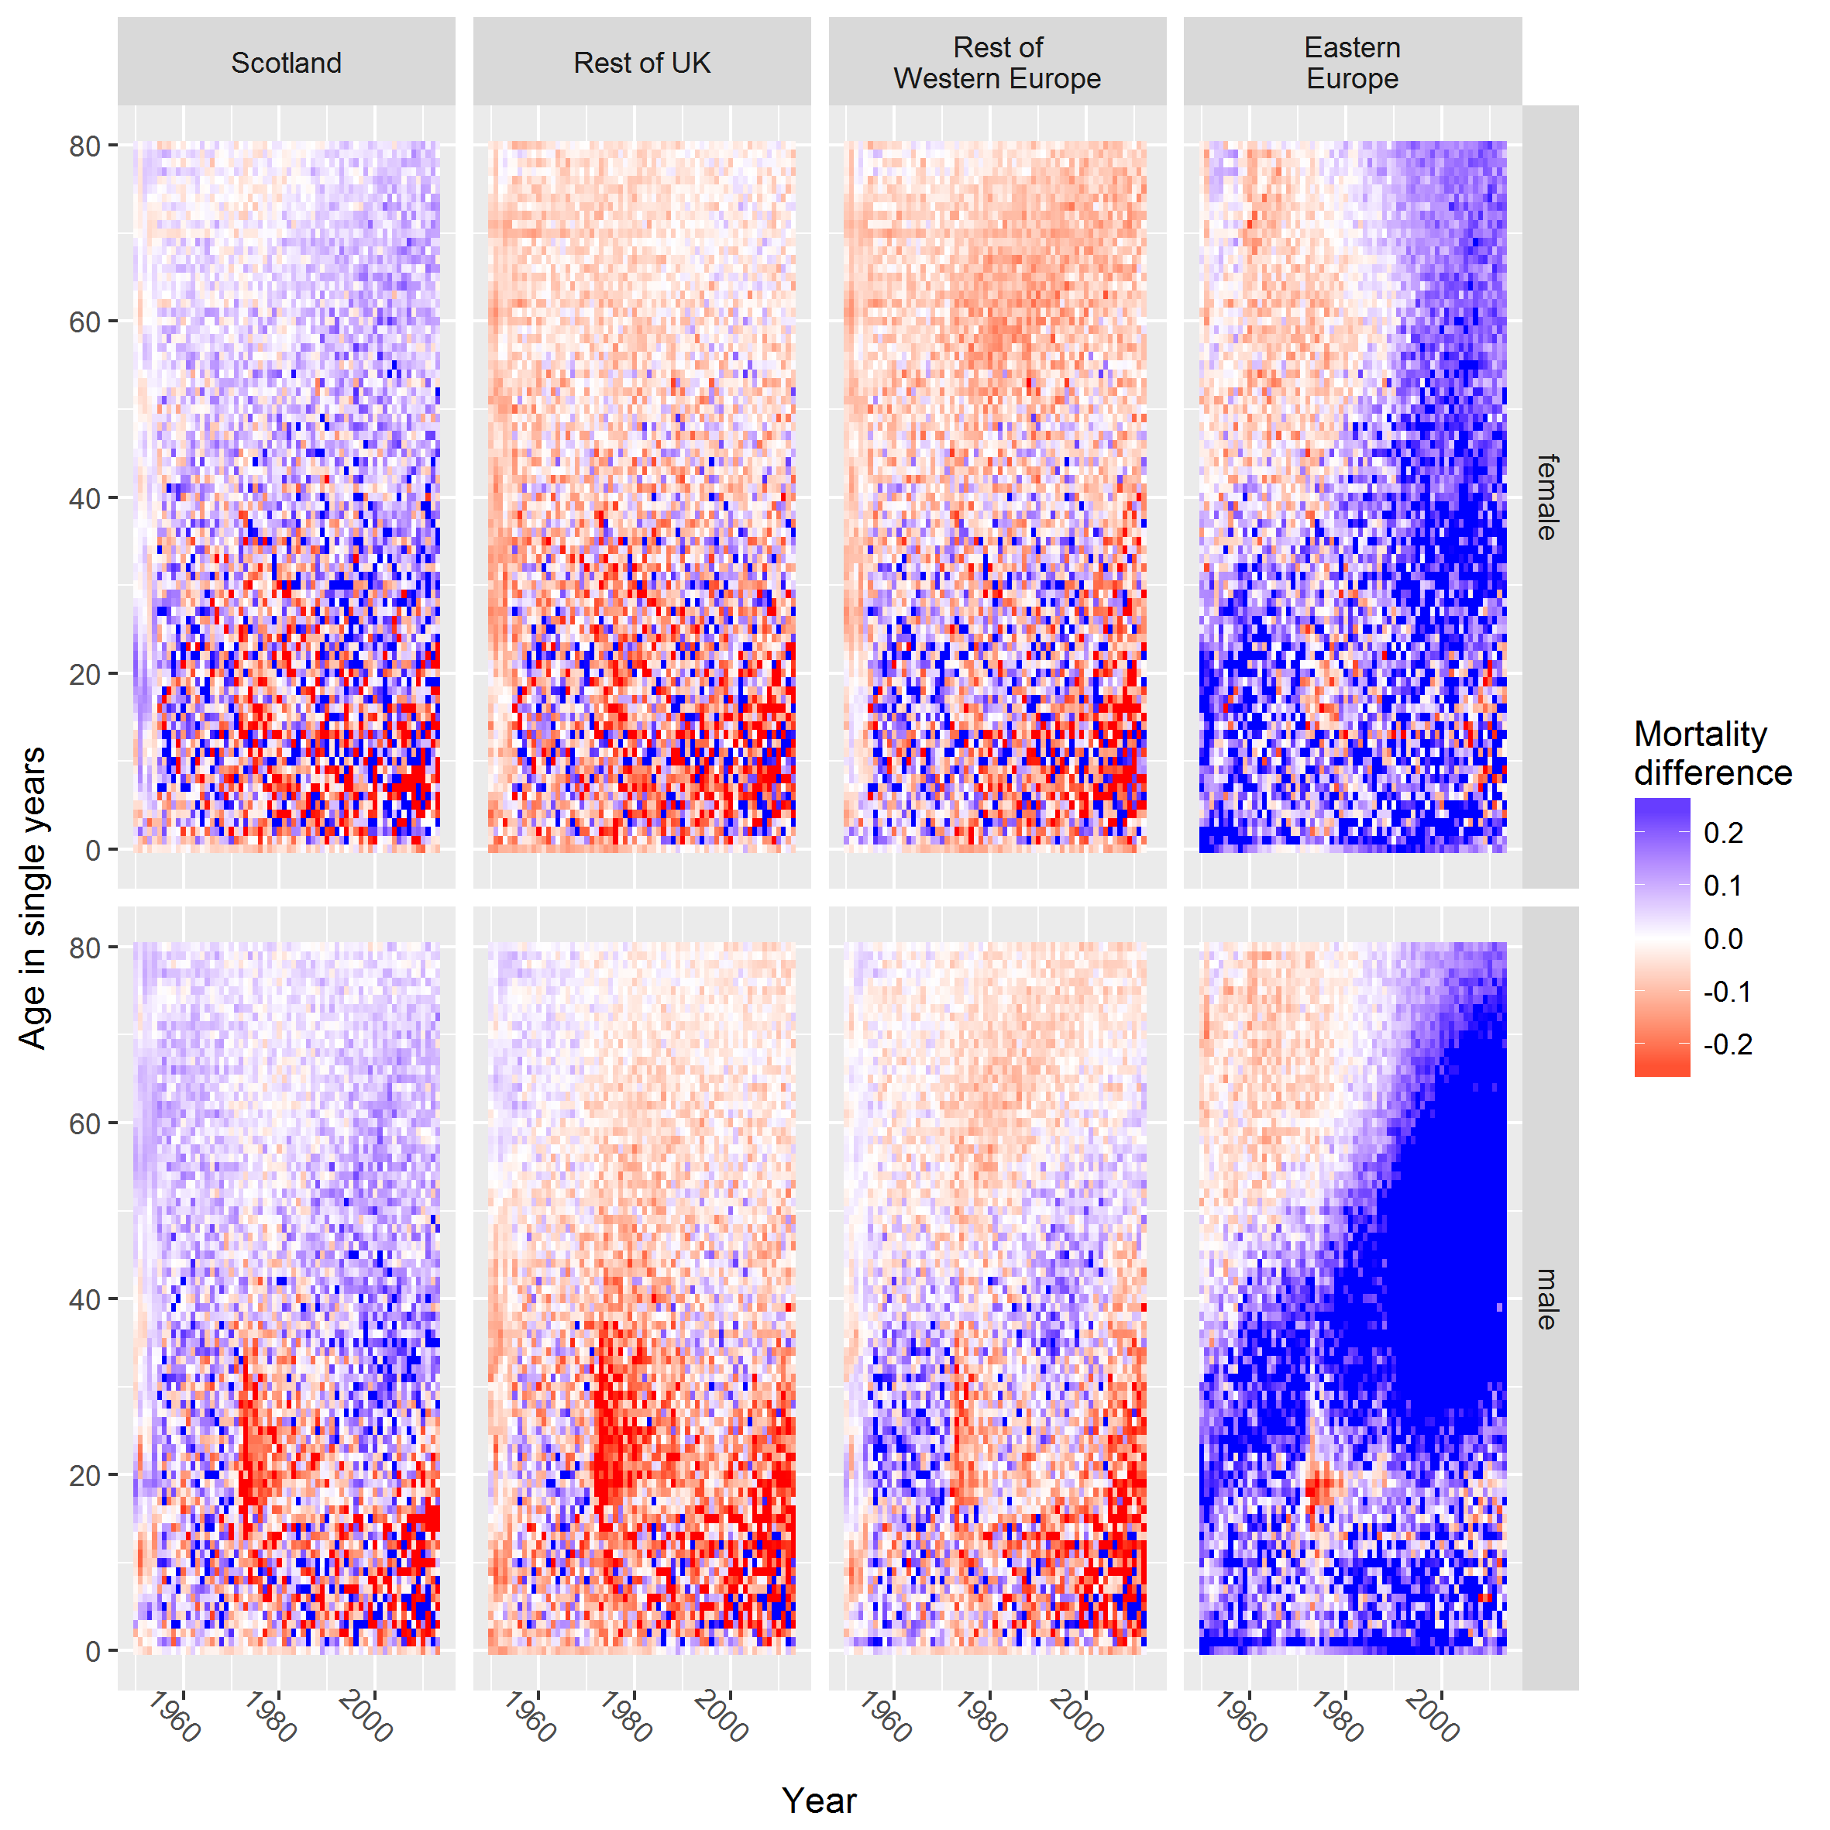

Figure 1 Comparative level plots (CLPs) for age-year specific mortality in Northern Ireland compared with other population groups. Differences shown are differences in log­10 ­­ mortality rates, truncated within the range -0.30 to 0.30. Rest of UK comprises England & Wales (GBRTENW) and Scotland (GBR\_SCO); Rest of Western Europe comprises Austria (AUT), Belgium (BEL), Switzerland (CHE), East Germany (DEUTE), West Germany (DEUTW), France (FRACNP), Scotland (GBR\_SCO), England & Wales (GBRCENW), Ireland (IRL), Luxembourg (LUX) and Netherlands (NLD); Eastern Europe comprises Estonia (EST), Lithuania (LTU), Latvia (LVA), Slovenia (SVN), Slovakia (SVK), Poland (POL), Ukraine (UKR) and Belarus (BLR) Source: Human Mortality Database

Within Figure 1 a distinct asymmetric red vertical band is evident for male population comparisons, stretching between around ages 15 and 40, beginning in 1972. Mortality rates for young adult males (aged approximately 18 to 22 years) increased briefly above those seen in Eastern Europe (right column), even though mortality rates in Eastern Europe have tended to be much higher than those for those born after the establishment (and subsequent collapse) of the USSR; this is evident in the blue diagonal triangular features seen in these CLPs. A similar pattern is not observed for female populations. The rest of this paper proceeds incrementally from this initial observation, beginning with level plots and summary statistics of mortality rates and death counts observed in the age groups most affected, then proceeding to describe and fit the structural model developed in order to represent the characteristics of this feature.

## Data and Methods

Data on all-cause mortality and population size, disaggregated by gender, age in single years and year, were extracted from the Human Mortality Database (HMD). (University of California, 2017) Mortality rates were calculated by dividing death counts by population exposure (adjusted population counts), with a continuity correction of 0.5 added to both numerator and denominator due to the use of the log scale and Northern Ireland’s relatively small population size. All data management and analyses were performed using the R statistical programming environment. (R Core Team, 2016) All code produced in this context of this research is available from the following github repository: REDACTED]

### Use of Lexis surfaces in a model development workflow

One of the key innovations of this paper is in using Lexis surfaces at multiple stages in a broader research workflow. The aim of the workflow was to select and build an appropriate structural model for characterising the salient features identified through visual exploration of Lexis mortality surfaces. As discussed above, this began with noticing an unexpected feature when comparing Northern Ireland’s mortality surface against a range of comparators. Variations of the Lexis surface are then used at a range of subsequent stages in data exploration, model development and testing, and the visualisation of model predictions and outputs.

### Initial visual exploration of data

In the first stage of the analysis, mortality rates by age and year are explored visually using Lexis surface level plots for a wide range of ages. (Minton, 2014; Vaupel, Wang, Andreev, & Yashin, 1997) In the second stage of the analysis, equivalent level plots are produced for the age groups 15 to 45 years inclusive, as the bulk of the distinct mortality pattern appears to occur at this age; a simple count of deaths within the affected age groups by year is also produced.

### Model development strategy and specification

In the third stage of the analysis, a model is developed to reproduce the main features of the level plot, with the ID function modelled separately from underlying mortality trends. The considerations and approach used to develop this model specification are discussed in more detail in Appendix B.

A key feature to note is that three distinct ‘phases’ of underlying mortality improvement are included in the model. These are: Phase one: 1922 to 1938, in which there was a moderate rate of drift; phase two: 1939 to 1955 inclusive, in which there was a rapid rate of drift (i.e. fastest improvement in mortality, despite including World War Two); and phase three: 1956 and later, in which there was a slow rate of drift. A ‘pen portrait’ indicating these phases is included in Figure 3b, and the key shape of the ID (‘Troubles’) function is shown in Figure 3a. To represent these three distinct phases, the linear model specification allowed for separate intercept and slope terms for each phase, in addition to a parameter for representing the Troubles shape which will be discussed in more detail below. More formally, the model specification is as follows:

$$l_{i}\left(t\right)= β_{0, i}^{\left(P\right)}+ β_{1, i}^{\left(P\right)}t^{(P)}+β_{2,i}T\left(t\right)$$

$$T\left(t\right)= {(1-k)}^{(t-1972)} IFF t≥1972;0 otherwise$$

Where $l_{i}\left(t\right)$ indicates the $\log_{10}$ mortality rate for males of age $i$ in year $t$, the superscript $\left(P\right)$ indicates which of three distinct phases in mortality improvement to which year $t$ belongs, and $t^{(P)}$ indicates the number of years since the start of the mortality improvement phase to which year $t$ belongs. (Phase 3 was the ‘reference period’ in the regressions used.)

#### Operationalising and parameter tuning for the impulse-decay (‘Troubles) function

In the above model, an ID (‘Troubles’) function, T(t), is introduced to represent a particular form of mortality risk change that appears consistent with both domain knowledge of this history of the conflict, and also the particular pattern of change in age-specific mortality as shown in Figure 1 and Figure 2. This parameter operationalises the concept that the Troubles followed a single ID pattern over time, with events in the years prior to 1972 leading to a tipping point, an initiation in sectarian conflict that, once initiated, was then sustained through tit-for-tat violence, as might be expected in sectarian conflict in which violence from one side is likely to be met with reprisal attacks from the other side. Visually, this a change in underlying conflict intensity is shown in Figure 3a, in which there is first a sudden increase in intensity, followed by a slow decay in this intensity over time.

$T\left(t\right)$ is the function which models the mortality effect of the conflict, i.e. the ID (‘Troubles’) function. The rate of decay in additional mortality is modelled using the parameter $k$, and can have any value from 0 to 1 inclusive. Numerical optimisation is used to select k such that the AIC (penalised model fit) is minimised. [REF to AIC]

Not that, given $k$, the ‘half-life’ of the conflict, i.e. number of years it takes for the additional log mortality risk to fall by half, can also be calculated using the formula $λ_{1/2}= \frac{log⁡(\frac{1}{2})}{\log{(1-k)}}$.

#### Use of Lexis surface visualisations for model diagnostic purposes

An innovative methodological innovation developed in this research is the use of CLP Lexis surface visualisations of *model residuals* (differences between observed and predicted age-year specific log mortality values). In these model residual level plots, red cells indicates that the model overestimates mortality rates, and blue indicates that the model underestimates mortality rates. The shade/intensity of these reds and blues indicates the magnitude of divergence between predicted and observed values, with darker shades indicating greater divergence.

The key intuition when looking at the residuals surface is that *better models will tend to look ‘noisy’,* with no clear patches of red and blue cells. A ‘noisy’ appearance suggests that the model is relatively effective in representing the underlying structure of the mortality surface, and that variations from the prediction surface are random. A surface with clear patches or regions of reds and blues indicate, instead, that the model does not yet adequately incorporate a key structural feature of the mortality surface, and so a new model specification, with additional terms to represent this feature, should be considered.

The use of Lexis surfaces to explore model residuals can therefore identify ways in which the model may be structurally inadequate, and should be seen as an important graphical diagnostic complement to standard summary measures of model fit such as adjusted R-squared and AIC.

Appendix C contains additional information about how the results of the model were used to produce estimates of the numbers and distributions (over time and age) of additional deaths from the Troubles, assuming the highly stylised ID function which the model contains is appropriate.

## Results

### Visual exploration of patterns

Figure 2 shows the Lexis surfaces of log­10 mortality rates for both genders and for each age between newborns and 90 years. Cells are coloured according to mortality rate. The legend on the right show which colours correspond to which mortality values. The values on this legend indicate the ‘number of zeros’ associated with the mortality risk, with ranges from 100or 1.0 risk for light blue at the top, then to 10-1 (one in ten) for lighter green shades, 10-2 (one-in-100) for lighter reds, to 10-5 (one in a million) for the brown shade at the bottom of the scale.

Figure 3b provides a stylised ‘pen portrait’ of some of the main features seen in figure 1. As with in many other countries, there is a much sharper increase in mortality risk once males reach adulthood, not observed to the same extent in female. In more recent years this can be seen by noting that for males almost all purple cells are seen in childhood, with cells at older ages coloured light or dark orange. This broadly corresponds to somewhere between a half to full order of magnitude increase in mortality risk after males reach adulthood compared with their risks in childhood. By contrast for females the difference in colour and shade in early adulthood is much less different to in childhood.

E:\repos\northern_ireland_troubles\figures\fig01_log_both_genders_all_ages.tiff

Figure 2: Levelplot of log10 mortality rates for males and females in Northern Ireland, 1922 to 2013. Cell colour indicates mortality risk. White cells indicate missing data. (Source: Human Mortality Database)

|  |  |
| --- | --- |
| Time  Conflict  Intensity  *Impulse*  *Decay* |  |
| 1. *Pen portrait of Parameter T(t)* | *b) ‘Pen Portrait’ of key features in Figure 1.* |

Figure 3 **Stylised representations of a) impulse-decay component of conflict; b) Key visual features in the Lexis surfaces shown in Figures 1 and 2** sss

Within Figure 3b, P1, P2 and P3 indicate ‘Phase 1’, ‘Phase 2’ and ‘Phase 3’, each demarcating periods of years in which there appeared to be systemic differences in the rate of change in mortality risk at different ages. The much more rapid falls in both female and male young adult mortality over Phase Two is evident in the Figure 2 level plot by noting that most of the cells in the age range 20 to 40 years are red before the late 1930s, whereas during this Phase they turn dark and light orange. This represents close to an order of magnitude fall in mortality risk at these ages over these years. This is despite the period including World War Two, indicated with a shaded polygon in Figure 3b.

The effect of the Troubles on mortality is evident by noting the faint vertical band of red cells which appears in the male level plot from around age 18 to 40 after the early 1970s. Before this red band appeared cells tended to be a darker orange shade (slightly under a 1-in-100 risk), and a slightly lighter orange/yellow shade after. No similar discontinuity at this age range after the early 1970s is evident for females. Figure 3 explores this pattern further, by plotting the number of deaths (not death rate) for males and females aged between 18 and 40 years. A grey band is added indicating the years 1971-1973. Male deaths increase in 1971 and 1972, peak in 1973, and then remain above those seen in earlier years for many years afterwards; no similar increase is seen for females. The Troubles had a longer term effect than WW2 on male mortality.

*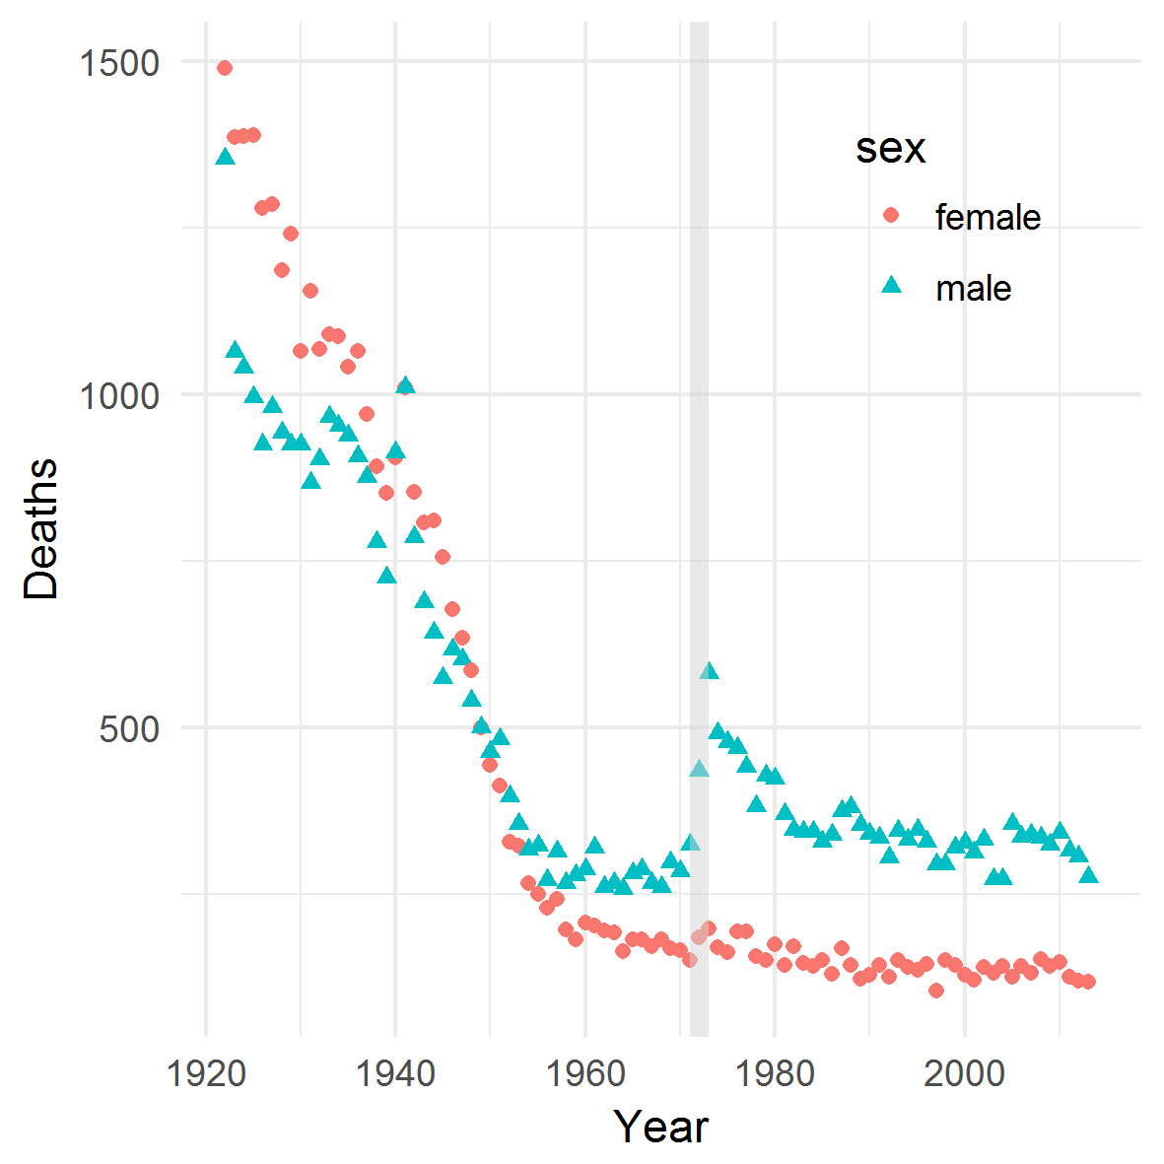*

Figure 4 Deaths for males and females between the ages of 18 and 40 years in Northern Ireland. Grey band indicates the years 1971-1973

Within Figure 3b, the large horizontal grey band indicates the age range 15 to 45 years, within which further analyses will focus. Figure 5 shows level plots for males and females for this age range only, using a slightly different colour scheme and range of log10 mortality values to before. Within this plot the effect of the Troubles on male mortality is clearer, and appears as a band of light red, then dark red, cells after the early 1970s after orange and dark red cells in earlier years. Again, no similar pattern is seen for females. The disruption to earlier trends for males appears mainly to affect males once they have reached adulthood, and to be sharpest at younger adult ages, from around the ages of 18 to 21 years of age.

*E:\repos\northern_ireland_troubles\figures\fig04_lmr_zoomed.tiff*

Figure 5 Level plot for log10 death rates for males and females between the ages of 15 and 45 years in Northern Ireland 1922-2013.

### Modelling

Figure 6 comprises three rows, each presenting a log10 mortality surface for males over the age range 15 to 40 years and for all years. On the top row, labelled ‘predicted’, the model predicted surface, including the parameter for the Troubles, is presented; on the middle row, labelled ‘counterfactual’, the model prediction for a counterfactual scenario, in which the Troubles term is not applied, is presented; and in the bottom row, labelled ‘actual’, the actual log10 mortality values from the data are presented. We can see that the model is relatively effective at capturing the broad pattern and features of the actual surface, though is clearly and necessarily a somewhat stylised representation of the actual data surface.

*E:\repos\northern_ireland_troubles\figures\fig05_prediction_surface.tiff*

Figure 6 Level plot for log10 death rates for males and females between the ages of 15 and 45 years in Northern Ireland 1922-2013.

*E:\repos\northern_ireland_troubles\figures\fig06_residuals_surface.tiff*

Figure 7 Level plots of residuals between modelled and actual log10 death rates by age and year for males 15 to 45 years in Northern Ireland, 1922-2013. Red indicates model overestimation, blue underestimation, and shade magnitude of error

Systemic bias in over-estimation or under-estimation of age-year specific mortality risks can be explored by looking at the surface of residuals between the predicted and actual surfaces, as shown in Figure 7: within this figure red cells indicate model over-estimation, blue cells under-estimation, and the shade of cells the magnitude of error. Systemic biases in these estimates appear as large ‘patches’ of cells with positive or negative residuals, as well as discontinuities in the data. There is a vertical band of red cells at younger ages in 1939; suggesting the model underestimates deaths in younger males during World War Two; this should not be surprising given the model does not include any terms to represent this event. The model has a best fit when k is 9.748%, suggesting a half-life of the Troubles of 6.76 years. A figure showing how the model fit varies with different values of k is shown in appendix D.

### Counterfactual estimation

Using the approach described in the methods section, the number of additional deaths attributed to the Troubles by the model can be estimated by applying mortality risks to population sizes under both the ‘with-Troubles’ and ‘without-Troubles’ scenarios. Figure 8 shows the estimated number of additional deaths at each age and year after 1972. These tend to be concentrated at the youngest adult ages, then reduce with age. This is further confirmed by extracting the coefficient associated with the Troubles for each age and for either gender. This is shown in appendix D.

E:\repos\northern_ireland_troubles\figures\fig_08_trbls_effect.tiff

Figure 8 Model estimated ‘excess deaths’ due to the Troubles from 1970 onwards, in males in Northern Ireland aged 15-45 years. Colours indicate numbers of deaths by age and year; the legend is shown on the right.

Table 1 shows the number of estimated additional male deaths by year and age group in five year intervals to the nearest whole number for each year from 1972 to 2013, with margins indicating the total number by year and age. This estimates nearly 2800 additional deaths by 2013, with over 1000 occurring in the first three years of the conflict from 1972 to 1975. Looking by age, over half of the estimated deaths (1470 out of 2776) are estimated to have occurred in boys and men aged between 15 and 25 years inclusive.

|  |  |  |  |  |  |  |  |  |
| --- | --- | --- | --- | --- | --- | --- | --- | --- |
|  | **Age Group** | | | | | |  |  |
| **Year** | [15,20] | (20,25] | (25,30] | (30,35] | (35,40] | (40,45] | **Total** | **Cumulative** |
| 1972 | 101 | 78 | 43 | 32 | 22 | 46 | 322 | 322 |
| 1973 | 86 | 67 | 39 | 29 | 19 | 39 | 279 | 601 |
| 1974 | 73 | 58 | 34 | 26 | 17 | 34 | 243 | 844 |
| 1975 | 64 | 50 | 30 | 23 | 15 | 30 | 212 | 1056 |
| 1976 | 56 | 43 | 26 | 21 | 13 | 26 | 186 | 1242 |
| 1977 | 49 | 38 | 23 | 19 | 12 | 23 | 164 | 1407 |
| 1978 | 44 | 34 | 20 | 17 | 11 | 20 | 146 | 1552 |
| 1979 | 39 | 30 | 18 | 15 | 10 | 18 | 130 | 1682 |
| 1980 | 35 | 27 | 16 | 13 | 9 | 16 | 116 | 1798 |
| 1981 | 32 | 24 | 14 | 12 | 8 | 14 | 104 | 1902 |
| 1982 | 28 | 22 | 12 | 11 | 7 | 13 | 93 | 1995 |
| 1983 | 25 | 20 | 11 | 9 | 7 | 11 | 84 | 2079 |
| 1984 | 22 | 18 | 10 | 8 | 6 | 10 | 75 | 2154 |
| 1985 | 20 | 16 | 9 | 7 | 5 | 9 | 67 | 2221 |
| 1986 | 17 | 15 | 8 | 7 | 5 | 9 | 61 | 2282 |
| 1987 | 15 | 13 | 8 | 6 | 4 | 8 | 54 | 2336 |
| 1988 | 13 | 12 | 7 | 6 | 4 | 7 | 49 | 2385 |
| 1989 | 11 | 10 | 6 | 5 | 3 | 6 | 43 | 2428 |
| 1990 | 10 | 9 | 6 | 5 | 3 | 6 | 39 | 2466 |
| 1991 | 9 | 8 | 5 | 4 | 3 | 5 | 35 | 2501 |
| 1992 | 8 | 7 | 5 | 4 | 3 | 5 | 31 | 2532 |
| 1993 | 7 | 7 | 4 | 4 | 2 | 4 | 28 | 2560 |
| 1994 | 6 | 6 | 4 | 3 | 2 | 4 | 25 | 2585 |
| 1995 | 5 | 5 | 4 | 3 | 2 | 3 | 22 | 2607 |
| 1996 | 5 | 5 | 3 | 3 | 2 | 3 | 20 | 2627 |
| 1997 | 4 | 4 | 3 | 3 | 2 | 3 | 18 | 2645 |
| 1998 | 4 | 3 | 3 | 2 | 2 | 3 | 16 | 2661 |
| 1999 | 3 | 3 | 2 | 2 | 1 | 2 | 14 | 2675 |
| 2000 | 3 | 3 | 2 | 2 | 1 | 2 | 13 | 2688 |
| 2001 | 3 | 2 | 2 | 2 | 1 | 2 | 11 | 2700 |
| 2002 | 3 | 2 | 1 | 1 | 1 | 2 | 10 | 2710 |
| 2003 | 2 | 2 | 1 | 1 | 1 | 2 | 9 | 2719 |
| 2004 | 2 | 2 | 1 | 1 | 1 | 1 | 9 | 2728 |
| 2005 | 2 | 2 | 1 | 1 | 1 | 1 | 8 | 2736 |
| 2006 | 2 | 2 | 1 | 1 | 1 | 1 | 7 | 2743 |
| 2007 | 2 | 1 | 1 | 1 | 1 | 1 | 6 | 2749 |
| 2008 | 1 | 1 | 1 | 1 | 1 | 1 | 6 | 2755 |
| 2009 | 1 | 1 | 1 | 1 | 0 | 1 | 5 | 2760 |
| 2010 | 1 | 1 | 1 | 1 | 0 | 1 | 5 | 2765 |
| 2011 | 1 | 1 | 1 | 1 | 0 | 1 | 4 | 2769 |
| 2012 | 1 | 1 | 1 | 0 | 0 | 1 | 4 | 2773 |
| 2013 | 1 | 1 | 0 | 0 | 0 | 1 | 3 | **2776** |
| **Total** | 816 | 654 | 388 | 313 | 208 | 395 | **2776** |  |

Table 1 **Model estimates of numbers of Troubles-attributable deaths in males in Northern Ireland by year and age group**

## Discussion

### Comparison of mortality estimates

(Smyth, 1998) estimated a total of 3598 deaths were attributed killings in the conflict between 1969 and 1998; this compares with 2661 estimated in my model between 1969 and 1998 in younger adult males in Northern Ireland only. Other total mortality estimates for the Troubles tend to be similar, with (McDowell, 2008) estimating slightly under 3700 deaths, and (Curran, 2001) estimating 3740 additional deaths between 1969 and 1999 (compared with my estimate of 2675 between 1972 and 1999). (Smyth, 1998) also found that a disproportionate share of deaths occurred in young adults, with a quarter occurring in people aged 18-23 years, and attributable deaths then falling at older ages. We found a qualitatively similar pattern of mortality burden by age, though with an even greater share in 18-23 age group, with 1053 deaths out of 2776, or 38% of all deaths, estimated.

My model, based only on all-cause mortality data, estimates around three quarters of the deaths that actually occurred, suggesting that the key modelling assumption - an initiation event leading to the sudden onset of a conflict whose intensity only slowly decays over many years – captures something of the essence of what occurred in Northern Ireland.

### Limitations and further research

There may be a number of reasons why our estimates are below death counts directly attributed to political violence, in addition to my use of a more restrictive demographic group. Firstly, I did not explicitly model to include the particularly high spike of deaths in 1973. Secondly, adult males experience an increase mortality once they reach adulthood, and young adult male mortality displacement effects may occurred in Northern Ireland after the Troubles began. For example rates of homicide risk and suicide risk tend to be inversely correlated, and that both disproportionately affect younger adult males. (Curran, 2001; Durkheim, 1951; Lester, 2002) It may be that the high rates of ‘bonding capital’ within Northern Irish communities, though responsible for the maintenance of sectarian conflict, were also protective against some other forms of mortality risk, such as alcohol and drug-related deaths, that otherwise would have claimed more young adult males. (Leonard, 2004) In the counterfactual scenario, therefore, it may well have been that some of those who did not die of sectarian violence instead died of some of these other causes, and so the net deaths ‘caused’ by the conflict may be less than the number of people who died of conflict-related violence. Another specific example of this may be that fewer people died of vehicle-related deaths if, as expected, travel was more restricted during the peak of the Troubles due to increased police and military presence; exploration of aggregate trends in road traffic deaths may therefore be useful to quantify the size of any such effect on deaths in the affected age groups.

Thirdly, the Troubles are likely to have led to some net emigration of those most-affected groups, and the model may not have been sufficient in accounting for emigration as a ‘competing risk’. Finally, not every death that occurred in a given year may have been attributed accurately to the year in which it occurred, especially if bodies were not found for many years if ever. Again, the effect of adjusting for these factors have not been explored, and further research is encouraged to do so.

One of the aims of this research was to estimate a counterfactual scenario in which the Troubles had not occurred; this was shown in the middle row of figure 6. This counterfactual was model dependent, and relied only on data from Northern Ireland. An alternative approach would be to aim to construct a ‘counterfactual Northern Ireland’ through an appropriately weighted average of mortality trend data from a range of other countries identified as otherwise similar to Northern Ireland for the period of comparison, an approach described as the Synthetic Control Method; (Abadie, Diamond, & Hainmueller, 2015) once again further research is welcome which uses this and other approaches to counterfactual estimation.

It has been suggested that the 1981 Irish Hunger Strike in the Maze prison, in which ten prisoners starved themselves to death, may have led to a renewed increase in violence; this could be tested by comparing the fit of a model specification assuming two distinct spikes in death risk, with the latter in 1981 or 1982, against the specification shown here, and again further research to explore this hypothesis is welcome. Finally, the role of cohort effects in mortality risk attributable to conflict has not been explored, and further research could do so.

The incidental and accidental origins of this paper therefore highlight the value of the data visualisation approaches employed, and of what Robert K Merton called ‘theories of the middle range’, of allowing social hypotheses to ‘emerge upwards’, inductively or abductively from data exploration, rather than simply being ‘applied downwards’, beginning in canonical social texts, then operationalised and empirically tested in a hypothetico-deductive fashion. (Menand, n.d.; Merton, 1968) This research is innovative in its use of Lexis surface visualisations for model diagnostics (as shown in Figure 7), and for showcasing an approach to model development which follows from effective and appropriate visual exploration of population data, and which uses Lexis surface visualisations throughout a broader process of research workflow.

The ID model used here can be applied to other populations whose mortality records exhibit the characteristic shape identified in young adult mortality surfaces for Northern Irish males, and will allow the human costs of sectarian conflicts to be compared in terms of the two key model attributes: the initial intensity (impulse magnitude) of the conflict, and persistence of the conflict (decay rate) after initiation. The model presented here therefore links health and place with cognate concerns about conflict, peace and the causes and consequences of political actions to population health. The specific model specification, including first an impulse component then an exponential decay, can be used to model particular types of mortality pattern disruption, likely attributable to violence or more general social disorder, even when only relatively limited all-cause mortality data are available, and specific death codes, such as ICD-10 codes, are not recorded consistently. This situation is likely to be the case both for less affluent nations in more recent years, as well as for historic demographic data from more affluent data. One specific benefit of the modelling approach used here is in allowing conflict-attributable mortality to be compared in terms of both initial intensity (the height of the initiation in the first year) and also duration in terms of decay rates and so conflict half-life.

If, once initiated, the conflict was largely endogenously sustained, this has important implications for how the various peace initiatives and processes which were attempted after 1972 should be interpreted in terms of their effectiveness. Up to seven prior attempts at bringing peace to Northern Ireland were made between 1969 and the Belfast Agreement of 1998, including the Sunningdale Agreement of 1973. It has been argued that what made the Belfast successful was the presence of key individuals acting effectively as ‘brokers’ in the complex social networks which had to be negotiated at the time.(Goddard, 2012) However, if the underlying dynamics of the model are accurate, then such factors may be greatly overstated. If the half-life of the conflict was 6.76 years and began in 1972, it follows that by 1994 the intensity of the conflict had diminished to around one-tenth of its initial level. (i.e. ${(1-k)}^{(1994-1972)}=0.105$). Similarly, by the time of the Good Friday Agreement in 1998 the underlying conflict intensity had diminished to around 7% of its initial value (i.e. ${(1-k)}^{(1998-1972)}=0.069$). Note that these intensity values apply to log10 mortality risks, so the actual level of decline of conflict intensity on deaths by the mid to late 1990s will have been even greater.

The model appears characteristic of a population that was in some senses ‘febrile’ or ‘fissile’ in its response to exogenous social, political and economic events and processes, and is to some extent consistent with previous attempts to model processes of violence as complex systems involving either systems of nonlinear equations or agent-based models. (Wright, 2006) A paper describing an agent-based model of processes and dynamics of civil war emphasises the punctuated equilibria – sudden increases in violence punctuating longer periods of relative calm – can be expected in such complex systems, and that it is important to consider the ways that agents involved in war adapt over time in their attitudes and behaviour.(Findley, 2008) Though it took a number of years, possibly three years, for the series of events which began in the late 1960s to lead to the initiation of conflict, this effect of this conflict was then sustained endogenously over many decades. This appears to represent the essence of cycles of violence driven by tit-for-tat processes of recrimination and revenge. For both sides, justice meant responding to violence with violence, a process of call and response in deadly conflict that, like an echo in a cave, only diminished slowly in intensity over time. Once this wave of conflict was initiated, it may have been that there was little that external agents could have done to either exacerbate or hasten the process of decline in violence.

# References

Abadie, A., Diamond, A., & Hainmueller, J. (2015). Comparative Politics and the Synthetic Control Method. *American Journal of Political Science*, *59*(2), 495–510. http://doi.org/10.1111/ajps.12116

Curran, P. S. (2001). Psychiatric implications of chronic civilian strife or war: Northern Ireland. *Advances in Psychiatric Treatment*, *7*(1), 73–80. http://doi.org/10.1192/apt.7.1.73

Durkheim, E. (1951). Suicide, a study in sociology. *New York Free Press*, *3*, 405. http://doi.org/10.2307/2088294

Findley, M. G. (2008). Agents and conflict: Adaptation and the dynamics of war. *Complexity*, *14*(1), 22–35. http://doi.org/10.1002/cplx.20232

Goddard, S. E. (2012). Brokering Peace: Networks, Legitimacy, and the Northern Ireland Peace Process. *International Studies Quarterly*, *56*(3), 501–515. http://doi.org/10.1111/j.1468-2478.2012.00737.x

Leonard, M. (2004). Bonding and bridging social capital: Reflections from Belfast. *Sociology-the Journal of the British Sociological Association*, *38*(5), 927–944.

Lester, D. (2002). The “troubles” in Northern Ireland and suicide. *Psychological Reports*, *90*(3), 722.

McDowell, S. (2008). Selling Conflict Heritage through Tourism in Peacetime Northern Ireland: Transforming Conflict or Exacerbating Difference? *International Journal of Heritage Studies*, *14*(5), 405–421. http://doi.org/10.1080/13527250802284859

Menand, L. (n.d.). *The Metaphysical Club.* New York: Farrar, Straus & Giroux.

Merton, R. (1968). *Social Theory and Social Structure*. New York: Free Press.

R Core Team. (2016). R: A language and environment for statistical computing. Vienna, Austria: Foundation for Statistical Computing,. Retrieved from https://www.r-project.org/

Smyth, M. (1998). *Half the Battle: Understanding the impact of “the Troubles” on children and young people*. Derry: INCORE. Retrieved from http://cain.ulst.ac.uk/issues/violence/cts/smyth1.htm

University of California, B. (USA); M. P. I. for D. R. (Germany). (2017). Human Mortality Database. Retrieved June 13, 2017, from www.mortality.org

Vaupel, J. W., Wang, Z., Andreev, K., & Yashin, A. I. (1997). *Population Data at a Glance: Shaded Contour Maps of Demographic Surfaces over Age and Time*. University Press of Southern Denmark. Retrieved from http://www.abebooks.co.uk/servlet/BookDetailsPL?bi=2944819605

Wright, S. (2006). A systems approach to analysing sub‐state conflicts. *Kybernetes*, *35*(1/2), 182–194. http://doi.org/10.1108/03684920610640308